WEST COAST SPATIAL DEVELOPMENT INITIATIVE
A case study for Geography learners, 2018
What is a Spatial Development Initiative? | - Abbreviated as SDI  - An initiative/plan to promote growth in underdeveloped/poor areas that has the potential to grow  - 10 of these plans have been identified | AIMS OF SDIs:  - Attract infrastructure and business investment to poor areas  - Promote agriculture, mining, tourism, environment, forestry, infrastructure (roads and railways), industry and ports  - Partnership between public and private sector
What and Where is the West Coast District?  (Location) | 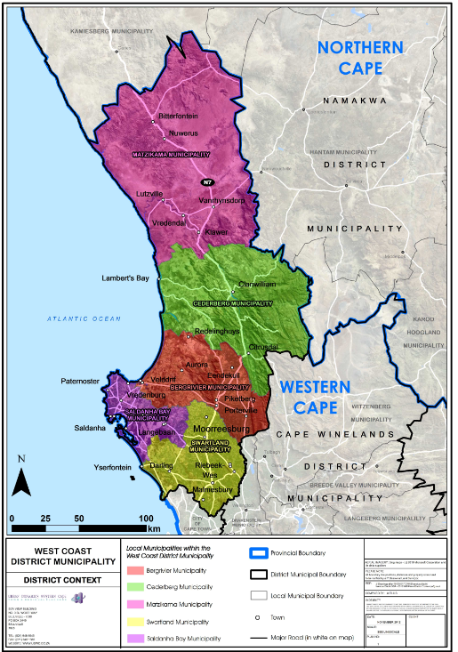 | - The West Coast District Municipality consists of five local municipalities:  - Saldanha Bay  - Swartland  - Bergrivier  - Cederberg  - Matzikama  - The Atlantic Coastline (±350 km) forms the western boundary and the eastern boundary is defined by mountain ranges  - The N7 national road ties all the municipalities together (“beads on a string”) and is the main freight route through the District  - The Port of Saldanha forms an important transport and economic asset
Wat are the main economic activities in the West Coast SDI? | Agriculture:  - Practiced around the majority of towns i.e. rooibos tea, fruit, grains, livestock, potatoes and wine  Fishing Industry:  - Lucky Star, Oranjevis, Sea Harvest and West Point  Aquaculture:  - Mussels, oysters and salmon farming  Tourism:  - Abundance of natural and cultural capital that attract tourist e.g. Langebaan lagoon & West Coast National Park  Freight transport:  - Imports and exports through Port of Saldanha  - Transport of freight through the district between Cape Town and Windhoek | Port of Saldanha:  - Well located deep water port  - Cargo facilities to handle exports and imports  - Exports – iron-ore  - Imports – 7 million tonnes of crude oil per annum  - Handles offshore extraction of oil and gas  Manufacturing Industry:  - Steel processing/manufacturing (ArcelorMittal)  - Fish processing and fishmeal industries  - Gas power plant  - Ship repair facility  Mining Industry:  - Saldanha iron ore handling facility  - Oil and gas storage  - Kropz phosphate mine  - Limestone and aggregate quarries
What are the aims/goals of the West Coast SDI? | Goals are:  - ensuring environmental integrity for the West Coast  - economic growth and the creation of job opportunities  - promoting social wellbeing of the community  - promoting bulk infrastructure and development services  - ensuring good governance and financial viability | Goals will be achieved through the following 3 key development areas:  - Vredenburg-Saldanha Major Regional Growth Corridor:  The Port of Saldanha attracts economic activity promoting the growth potential of the adjacent towns and nodes.  - Lower N7 Transport Corridor:  Malmesbury along the N7 road forms a regional node and creates the potential for growth. Moorreesburg and Piketberg are also nodes along the N7 road.  - Northern Rural Development Corridor:  The fertile Olifants River Valley agricultural production area is the primary economic growth sector followed by fishing and tourism.
What development projects are associated with the West Coast SDI? | Infrastructure:  - A sea water desalination plant  Increasing capacity of the Sishen-Saldanha railway Agriculture:  line linking iron ore mines in the Northern Cape to Saldanha harbour  - Upgrade of the N7 road  - Establishment of dedicated freight roads, which will require major road works  - Upgrade of the Port of Saldanha to expand the waterside and landside infrastructure to support the proposed IDZ  - Establishment of a regional waste facility in the Matzikama area  Renewable Energy:  - Renewable energy projects like solar and wind farms  Aquaculture:  - Major expansion of aquaculture zone in the bay of Saldanda  - As part of the Agri-Park initiative, Doringbaai, Lamberts Bay and Elands Bay were identified as Aqua-Hubs, supporting aquaculture production | - Expansion of the Clanwilliam Dam and Olifants River Irrigation scheme  - Agri-Park initiative as a network innovation system of agri-production, processing, logistics, marketing, training and support services to support land reform  - Vredendal, Clanwilliam and Malmesbury were identified as Agri-Hubs, supporting farmer production  Manufacturing:  - Fuel storage facility of the Mining, Oil and Gas Sector Company in South Africa (MOGS)  - Avedia and Sunrise Energy’s liquid petroleum gas (LPG) import and storage facilities  - Processing of other minerals on Northern Cape corridor and near the Port of Saldanha  Industrial Development Zone (IDZ):  - An industrial estate (Saldanha Bay) that leverages domestic and foreign investment to encourage value-adding and export-orientated manufacturing
What are the economic advantages of the West Coast SDI? | Advantages for local communities:  - Employment opportunities in industries, farming, infrastructure development and tourism  - Earning potential increases  - Poverty reduced  - Accessibility to services  - Standard of living increases  - Tourism provides for the buying and selling of arts and crafts for growth of the informal sector  - The growth of informal and formal economic activities along the development corridors of the SDI will increase the productivity and wealth of people in marginal areas | Advantages for the SAs economy:  - The SDI initiated links with the Northern Cape and Windhoek  - Provides access to resources of these areas  - The SDI promotes the development of new and existing infrastructure  - This provides access to different markets and assists with economic upliftment  - Promotes domestic and international trade  - Efficient transport networks to move raw materials and finished goods  - Good port facilities with international links  - Employment opportunities  - Sustainable water for domestic and industrial use and farming
