THE FOUR MAJOR INDUSTRIAL REGIONS OF SOUTH AFRICA.
- PWV Complex [Gauteng] [2019]
- Durban – Pinetown.
- SW Cape.
- PE –Uitenhage. [2019]
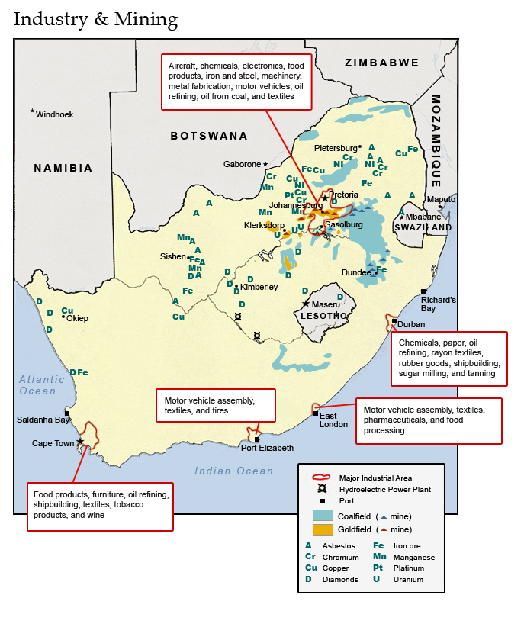
- PWV Complex [Gauteng]
IMPORTANT INDUSTRIES IN THE AREA.
- Iron and Steel products: Mittal Steel and AMCOR.
Iron and steel factories in Vander bijl Park and Vereeniging.
- Chemical and Gas products: AECI, SASOL at Sasolburg and Secunda.
- Engineering projects: Aviation [Atlas aircraft] and car assembly plants [BMW and Ford], tool and machine manufacturing.
- Clothing and cosmetics.
- Food and beverages / liquor.
FACTORS FAVOURING INDUSTRIAL DEVELOPMENT IN PWV. COMPLEX
- Need for mining equipment.
- An abundance or raw materials in the area. [see map on page 2]
- Large un-skilled, semi-skilled labour force.
- ESKOM provides electricity – near coal mines in Mpumalanga, [relatively cheap]
- Water supply; Vaal dam supplemented from Sterkfontein dams [Tugela transfer]
- Well-developed infrastructure – rail and roadways in place.
- Large market due to high population density and high spending power.

FACTORS HINDERING INDUSTRIAL DEVELOPMENT IN PWV. COMPLEX
- Water shortages – supplemented from Tugela Vaal and Lesotho Highlands project.
- Pollution. Air pollution from industry and water pollution from acid mine water.
- Vulnerable as more than 50% of SA industries located there.
- Congestion and pressure on resources due to large population concentration.
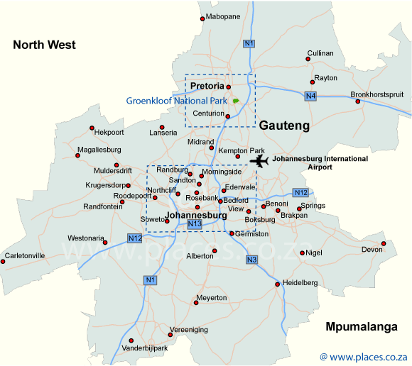
- Durban – Pinetown.
IMPORTANT INDUSTRIES IN THE AREA.
- Fuel refineries –raw fuel from Middle East – refined into petrol and diesel – SAPREF
- Chemicals –AECI = fertilizers, paint, soap.
- Sugar refinery – Rossburgh – Huletts.
- Textiles – Umkomaas.
- Light Industries – Pinetown – Shoes = Bata toughies school shoes.
- Ship Building and repairs; dry docks in Durban harbour.
- Paper industries – North Coast and Richards Bay.
- Industries related to Toyota car assembly plant – Isipingo.
FACTORS FAVOURING INDUSTRIAL DEVELOPMENT.
- Large harbour dealing with a variety of freight.
- Industries related to imported raw materials – Fuel refineries.
- Large labour force. Skilled and unskilled.
- Electricity is available.
- Well-developed infra structure – linked to PWV by road, rail and pipeline.
- High rainfall region ensures abundance of water.
FACTORS HINDERING INDUSTRIAL DEVELOPMENT.
- Undulating and mountainous landscape where there is few flat areas to build large industries on.
- Hot, humid climate that is not always conducive to favourable working conditions.
- Pollution.
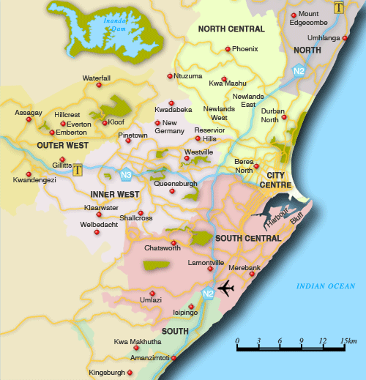
- Industrial development is limited as the harbour cannot develop further.

- SW Cape.
IMPORTANT INDUSTRIES IN THE AREA.
- Food processing. Fruit, wine, tinned fish, wheat for flour production.
- Textiles’ shoes and clothing.
- Ship repairs.
- Fuel refineries – Milnerton.
- Link industries –printers, publishers and packaging.
FACTORS FAVOURING INDUSTRIAL DEVELOPMENT.
- Harbour links the area to the rest of the world markets – on major transport routes.
- Raw materials – deciduous fruit, wheat, vegetables dairy and fish.
- Dry dock facilities for ship repairs.
- Skilled labour available.
- Large population creates a large enough local market to ensure success.
FACTORS HINDERING INDUSTRIAL DEVELOPMENT
- Expensive electricity – far from coal mines – Koeberg nuclear power plant nearby.
- High transport costs to largest market in PWV which is far away.
- Water shortages – use Palmiet water pump saving scheme to supplement water supply.
- Salaries are lower than in PWV which leads to lower spending power.
- No mineral raw materials in the area.
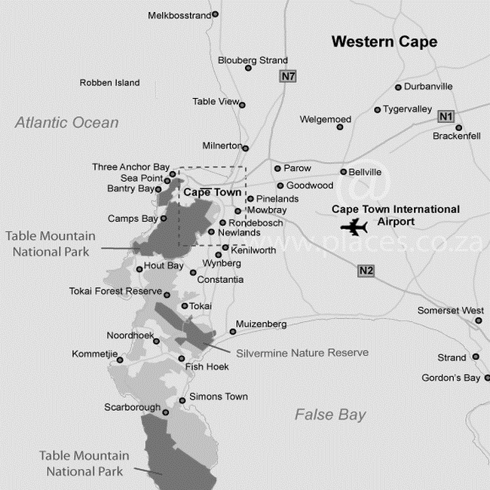

- PE –Uitenhage [2019]
IMPORTANT INDUSTRIES IN THE AREA.
- Car assembly plants: Ford [trucks], GM, Volkswagen, Chinese trucks [2017].
- Supporting industries; car parts, tyres, windscreens, seat covers etc.
- Textiles; wool and cotton
- Leather; shoe factories and car upholstery.
- Rubber products; tyres [Goodyear and Continental Tyres], rubber pipes etc.
- Fruit canning.
- Salt works.
FACTORS FAVOURING INDUSTRIAL DEVELOPMENT.
- Harbour centrally placed for inland markets and coastal markets.
- Raw materials; wool [Karoo merino farms,] cotton, deciduous fruits [Addo citrus]
- Harbour; import hub for car parts.
- Harbour; export hub for car to Europe and Africa.
- Car industry has stimulated supporting industries; spare parts, small engineering works etc.
- Low Labour costs.
- Coega Harbour project; deep water harbour for extra-large ships. The Coega Industrial development Zone has attracted a wide variety of new investment to the area. Chines truck assembly plant, GM has locate its spares dept. to this area etc.
FACTORS HINDERING INDUSTRIAL DEVELOPMENT
- No local raw minerals.
- Expensive electricity.
- In the 1980’s Ford relocated its car assembly plant to Pretoria.
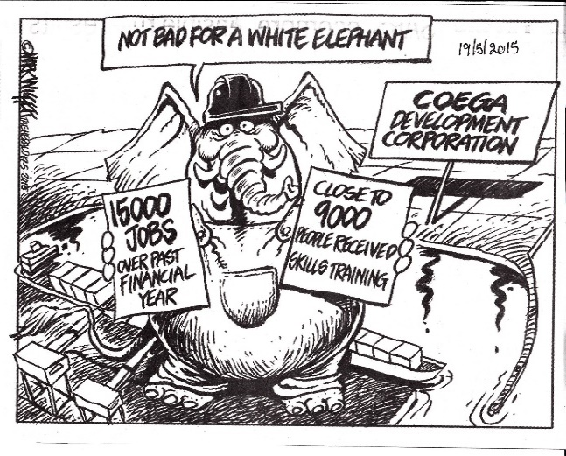
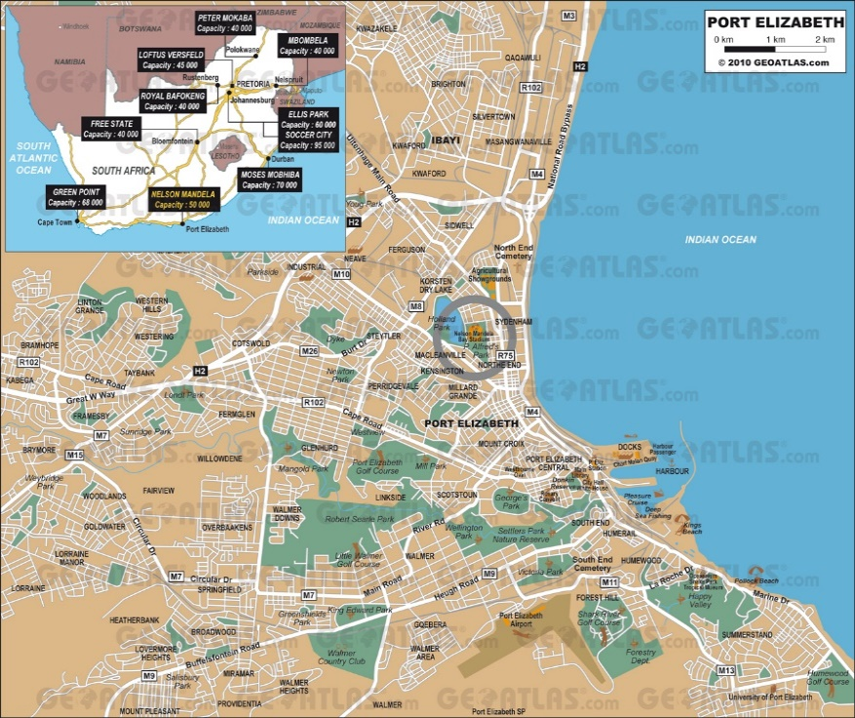
THE HERALD
14 July 2017
Step-up in status of Coega IDZ
Special Economic Zone brings benefits which include tax breaks and employment incentives.
Bring with it a range of new incentives and benefits, South Africa’s first and largest Industrial Development Zone, the Coega IDZ is poised to officially convert to a Special Economic Zone [SEZ].
This was confirmed by the Coega Development Corporation, which has already begun referring to the site as an SEZ. It confirmed the imminent new status of the zone when it announced yesterday that nine SMME’s had been awarded R30 million worth of contracts there. It said the new status would become official as soon as it was ratified by the Department of Trade and Industry.
The department defines SEZs as geographically designated areas of a country which are set aside for specifically targeted economic activities, supported through special arrangements [that may include laws] and systems that are often different from those that apply in the rest of the country.
The department is expected to provide a number of incentives towards ensuring the growth of SEZs, revenue generation, the creation of jobs, the attraction of foreign direct investment and international competitiveness.
The incentives that tenants are expected to success include; preferential corporate tax rate, building allowance, employment incentives and access to an allowance.
Commenting on its R30 million investment into nine SMMEs, a Coega spokesman said; “As an empowerment driven organisation, the CDC is conscious of the important role that the small business sector plays in unlocking economic growth in Nelson Mandela Bay and South Africa.”
“Our dedicated SMME unit was specifically established to support [smaller contractors] in line with our vision to be a catalyst for championing of the socioeconomic development”
“Contracts given to small contactors from the Bay had been awarded over 12 months and included three projects that involved CCA fencing, MM engineering and a custom control area – building in Zone 1 of the SEZ.”
“The construction work on these projects includes brick work, electrical, structural steel, civil works and landscaping among others.”
He also announced the construction of South Africa’s first factory to manufacture liquid petroleum gas cylinders for MM Engineering at the SEZ as another major boost for small contractors, with contracts worth R22 246,847 allocated to them.
Strategies for Industrial Development.
Apartheid industrial development strategies.
From the 1960’s the strategies had the following intentions:
- To provide employment in or just outside the borders of the new ‘Homelands’.
- To help the poorest areas to develop economically by opening factories in or near the ‘Homeland’.
- To create a ‘white’ South Africa apart from the ten self- governing ‘Homelands’.
A] Industrial development points.
These growth points were localities in or near the ‘black states’ where industrial development would take place, where black workers could live within the homeland and travel to the nearby industrial point.
B] Regional de-concentration points.
Points close to Metropolitan areas towards which future industrial growth could be developed to reduce over concentration in already established industrial area.
C] Metropolitan areas.
The existing city areas were already attractive to private investors because of the geographical advantages they enjoyed.
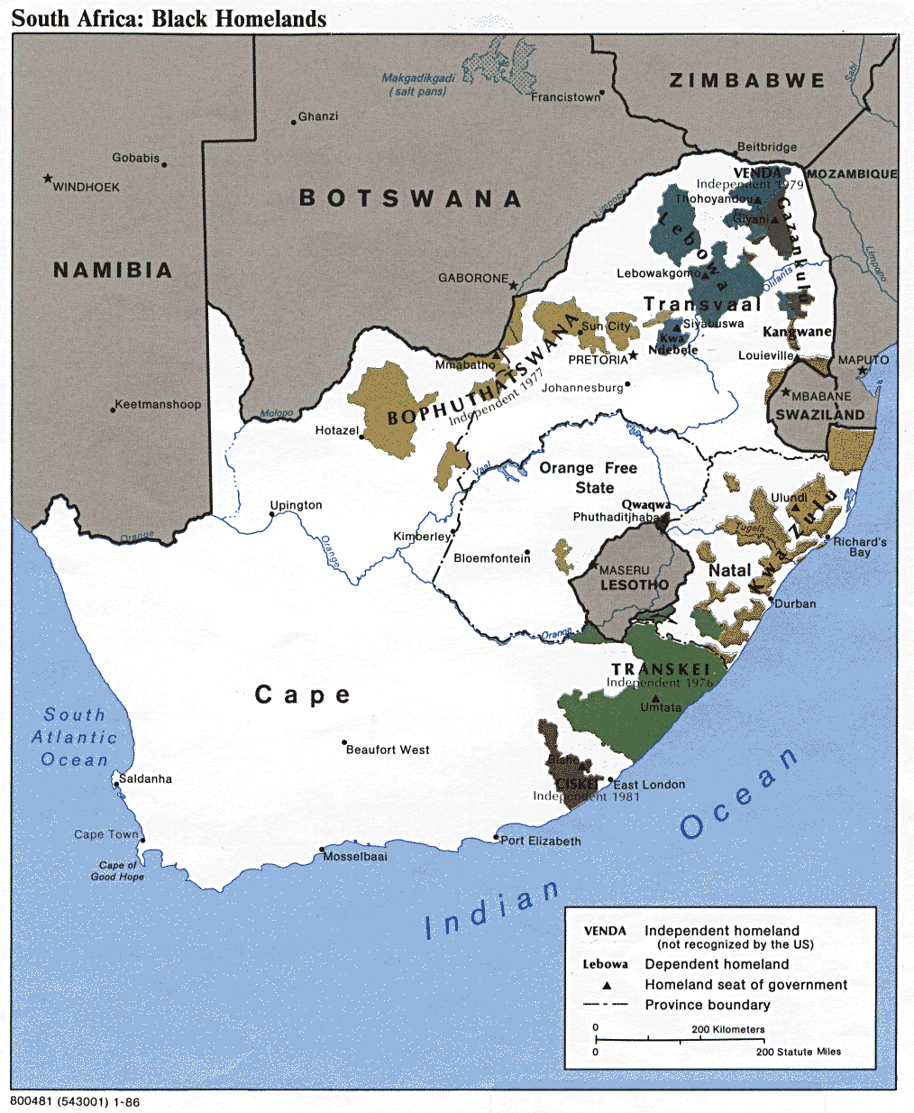
Incentives to attract investors.
- Financial help with land and buildings.
- Tax rebates of up to 60%.
- Relocation allowances [R500 000]
- Wage subsidies.
- Training grants ]125% of cost]
- Electricity subsidised.
This Strategy was not a success for some of the following reasons;
- There are very few mineral resources within the ‘Homelands’
- Agriculture within the ‘Homelands’ hampered by over population.
- Manufacturing failed to provide enough jobs per year.
- Most of the income was spent outside the ‘Homelands’.
- Administration used up ±79% of the ‘Homelands’ budget.
- Education limited by lack of teachers, inadequate buildings and lack of school funds.
- Abuse of incentives. Investors moved to new areas once the incentives expired.


Post- Apartheid industrial development strategies.
Reconstruction and Development Programme [RDP] 1994 - 1998
The regional industrial development programme of the Apartheid era proved to be economically unsound and a failure. The incoming democratic government replaced the Apartheid era strategy with RDP in 1994 and it came to an end in 1998. The RDP achieved some significant successes:
- Housing; by 2001, over 1.1 million RDP houses constructed accommodating an estimated 5 million of the estimated 12.5 million without adequate housing.
- Water: by 2000 a total of 236 projects had supplied clean water to nearly 4.9 million people, mostly in the former ‘Homelands’
- Electrification; by 2000and estimated 1.75 million homes had been connected to the ESKOM national grid. The proportion of rural homes with electricity grew from 12% to 42%.
- Land reform; by 1999 some 39 000 families had been settled on 3.500 Km² of land.
- Healthcare; by 1998, 500 new clinics gave an additional 5 million people access to primary health care.
- Public Works; community based Public Works Programme provided employment over five years to 240 000 on road building schemes and installation of sewage, sanitation and water supplies.
The GEAR Plan 1996 – 2003 [Growth Employment and Redistribution]
This was an attempt to improve and extend the RDP. The focus was to ensure people were given jobs, housing and clean water. The GEAR plan also focused on developing Trade, Investment and Private enterprise.
Aim;
- Develop infrastructure and create 400 000 new jobs per year.
- Encourage trade.
- Improve output.
- Increase investment.
- Use better business procedures.
- To privatise state run organisations.
GEAR was successful in attracting foreign investment and increasing demand for South African products. The GEAR policy was rejected by the Trade Unions who favoured BEE policy that reduced social expenditure.

The concept of Industrial Development Zones [IDZs] 1996 – 2017
1996 saw the beginning of an ambitious development plan. This is a State backed plan and is based on two initiatives;
- Spatial Development Initiatives [SDI]
- Industrial Development Zones [IDZ] which are cores of development within the SDI’s.
Industrial Development Zones.
- A total of eight IDZ’s have been selected.
- These are either ports or are near airports.
- Plan is to develop and upgrade the infrastructure to make these sites more attractive for investment and to create modern industrial zones.
- Government offered ‘Incentives” to new investors.
- State developed new road and rail links to these sites where needed.
- By 2012 three IDZ’s were operational. Richards Bay – East London and Coega, the new deep harbour in Algoa Bay / Port Elizabeth.
- In 2012, the State conceded that the program had “missed the mark” by failing to attract enough foreign investors.
Factors that hindered the IDZ programme.
- In 2012 the greatest hindrances was the inability off ESKOM to provide cheap and reliable power.
- Rio Tinto cancelled a R22 Billion investment for an aluminium smelter at Coega because of the [then] unreliable power supply from ESKOM.

East London IDZ
The ELIDZ was initiated by Government In 2002, with a total investment of R2 Billion for infrastructure within the development zone. It is designated for specialized industrial activity. It is specially set up for Light Industry manufactures in search of “global competitiveness and new market entry”
Factors that attract investment.
- A secure manufacturing environment.
- Controlled access.
- Proximity of key transport networks;
Harbour on Buffalo River, recently expanded airport capacity and train links.
Examples of development / investment.
- Since its establishment in 2002, the ELIDZ has attracted more than R7.3 billion in private sector investment from 45 investors.
- As of 2016, 75% of invest is foreign.
- 32% of the investment is in the automotive sector. [Mercedes SA is locates in EL]
- The ELIDZ has attracted export orientated investors.
- During 2015, R3.8 Billion of total inputs used by manufactures in the ELIDZ were locally sourced. [Statistics South Africa]
- Outputs worth R2.6 Billion from manufactures were export bound.
- In 2016 there were seven projects at different stages of construction.
- These include four new investors eg.
Information and Communication technology, Renewable energy, specialised manufacturing and Aquaculture sectors. That are preparing to break ground and start construction in the near future.
- Other construction projects at the planning phase are a Wind farm in the area and an upgrade to the electrical infrastructure of the area.
- The ELIDZ has also established a research and development {R&D] platform.
- The ELIDZ Science and Technology Park [ELIDZ STP] is to promote testing and prototyping of different technologies and new inventions.
- The ELDZ STP encourages innovators and their start-ups to locate themselves within the ELIDZ.
- The STP aims to facilitate creation of technical solutions to problems and to assist companies in adopting innovative approaches in all their operations.
Examples of new industry.
- Foxtec- Ikhwezi – automotive component manufactures. They export 87% of the products to Germany and the USA. They recently celebrates 10 years of successful manufacturing in the zone. They produce aluminium struts for the automotive industry. Produce an average of 5 million struts per annum.
- Sundale Dairy. Agro-processing enterprise in the ELIDZ. This is a good example of local sourcing and backward linkages with the local economy. Sundale is a family owned business which started in 1981 with a few cattle. It has since grown to become the biggest fresh dairy processing plant in the Eastern Cape. It is one of the most advanced facilities in RSA. In 2010 Sundale opened a R140 million highly specialised dairy processing plant in the ELIDZ. It produces Yoghurt, Butter, Milk, Dairy Blends, and Cheese from this facility within the ELIDZ. It produces 3 million litres of dairy products a month and sources milk from 14 farms in the Eastern Cape.
Some of the dairy farmers are located near Port St Johns, which means that the facility in the ELIDZ is supporting job creation in the Port St Johns area.
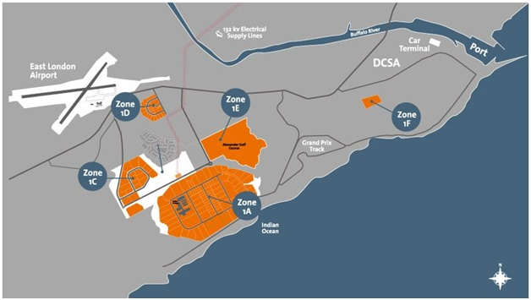

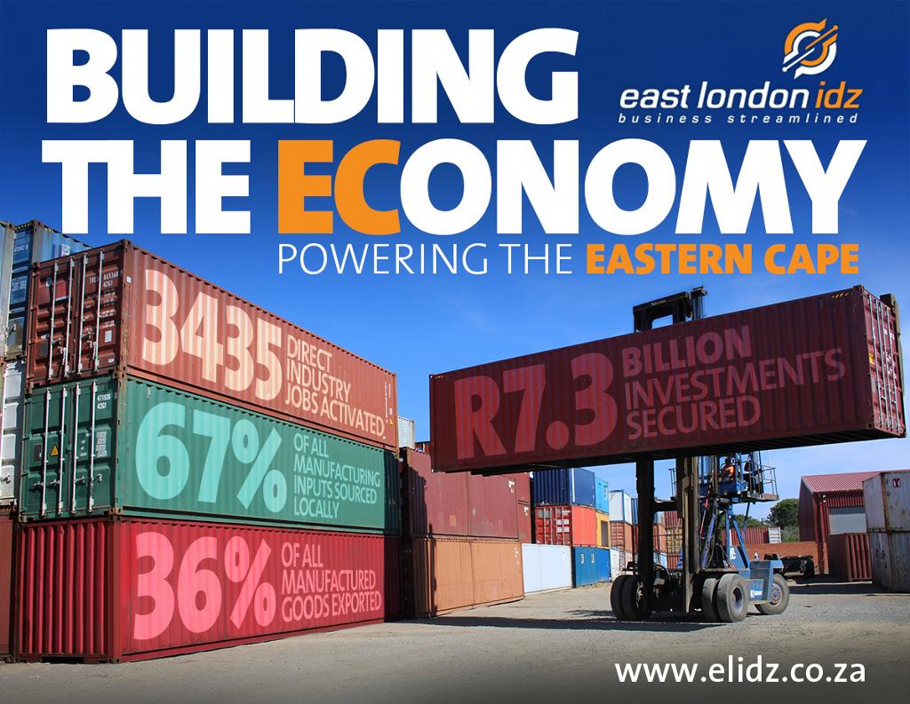

The concept of Spatial Development Initiatives [SDI’s] 1996 – 2017
Closely linked to the IDZ’s is the SDI development programme to initiate and support a series of development corridors stretching across parts of RSA and in some cases into our neighbouring countries.
AIM
- To develop and improve existing transport infrastructure.
- Smaller towns along the road, rail and other transport links also benefit from development of infrastructure and passing traffic.
- Makes area more accessible to tourism.
- Improves transport links to smaller communities.
- To correct some of the damage done by apartheid era strategies.
- To create an attractive environment for private sector investment.
- To initiate and support economic activities along those transport corridors.
Spatial Development Initiatives | Economic sectors supported.
Maputo Development Corridor. | Agriculture, forestry, mining , manufacturing, tourism, port development and transport infrastructure
Wild Coast and Lubombo SDI’s | Agriculture and transport infrastructure.
Fish River SDI | Agriculture, manufacturing, tourism, port development [Coega, Port Elizabeth, East London.] and IDZ development.
KZN and Richards Bay SDI’s | Manufacturing and Port development, [Durban and Richards Bay] and IDZ development.
Platinum and coast to Coast SDI’s | Transport corridor.
West Coast Investment Initiative. | Agriculture, tourism, manufacturing and IDZ development. [Saldanha Bay]

These initiatives are expected to increase the range of economic activities performed an each area. This should increase productivity and wealth of marginal areas in RSA and raise the standard of living of people living there. These plans are progressing well and positive results can be seen in areas like port developments in Coega, Durban and Richards Bay.
Criticism.
- Developing spaces rather than people in those spaces.
- Developing infrastructures by employing companies from outside of the development area rather than people living in the SDI’s.

The Maputo Development Corridor SDI. [November 2018 exam]
Introduction
The Maputo Development Corridor [MDC] is the largest and most successful development corridor in southern Africa. It connects South Africa’s hub of Gauteng with Mozambique’s capital, Maputo, and its vital port. The corridor also links to the agricultural products and minerals of Mpumalanga and Limpopo provinces, two land locked regions.
Goals of the MDC
- To stimulate economic growth along a 600km corridor.
- To link the economies of Mozambique and South Africa.
- To give isolated north eastern parts of South Africa access to Gauteng and to overseas markets through the port of Maputo.

Achievements of the MDC [1996 – 2012]
- Reconstruction of the N4 Maputo Toll Road.
- Improved custom post at the border for efficient / quicker transit. Some cargoes need to be checked for contraband /smuggling. This now takes 5 hours instead of three or more days.
- Expansion and deepening of the port of Maputo so larger container ships can use the port. This is the closest port to Gauteng.
- New Mozal aluminium smelter near Maputo with a capacity of 500 000 tons a year.
- A gas pipeline from Mozambique to Secunda where SASOL converts natural gas to diesel and aviation fuel [a cleaner process than converting coal to fuel.]
- Maintaining the gas pipe line has created jobs for Mozambique and SASOL has drilled many boreholes to provide clean water for Mozambique villages and also refurbished schools and clinics.
- High voltage powerlines carrying electricity from Duvha [RSA] power station to Maputo.
- Opening of new factories and services along the 600km corridor.
- Planting of forest and sugar plantations.
- Construction of mills to process wood and sugar cane.
- Tourism development; this corridor is linked to the Kruger National Park. This has created more jobs for game guides, traditional craft makers and hotel and lodge workers.
- Established an institute to teach Portuguese and English.
Remaining challenges
- The border is open 18 hours a day. This needs to be increased to a 24 hour service to speed up the processing of trucks etc.
- The State owned railway, Spoornet, was slow in participating in the MDC. It took a long time to upgrade its railway lines to the required capacity to achieve faster delivery times. Only in 2011 did it increase the service from 15 to 38 trains a week.
Conclusions
- The success of the MDZ is an example for other IDZs.
- A reason for its success was the efficient non- government organisation {NGO} overseeing all aspects of the initiative.
- Its use of an NGO public – private partnership to handle finances on behalf of all participating bodies.
- The private sector has committed an estimated figure of well beyond R35 billion worth of investments in Southern Mozambique and Mpumalanga.

The Wild Coast Development SDI. [November 2017 exam]
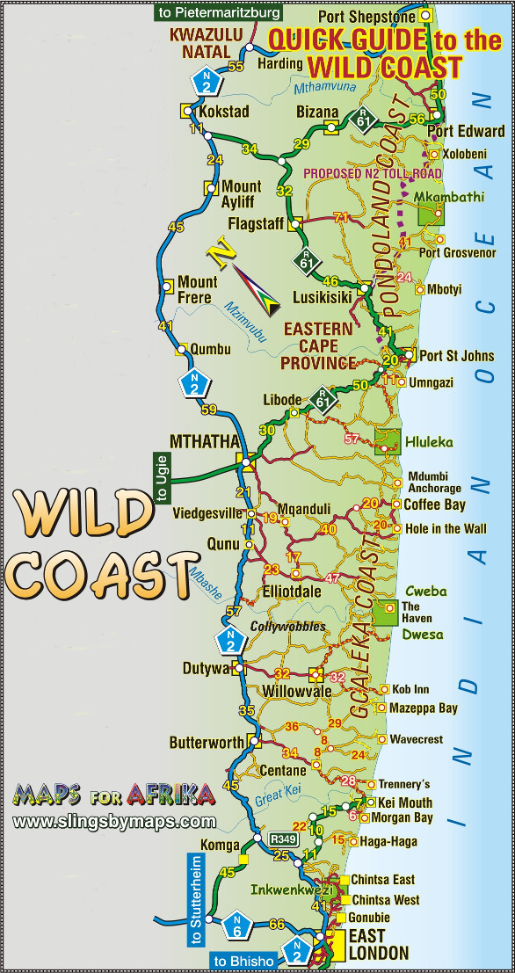

Where
The Wild Coast SDI stretches along the Eastern Cape Coast between East London and the KZN border.
What
- More than 30 commercial projects in tourism, forestry and agriculture.
- The area has potential for the cultivation of sub-tropical fruit and nuts, diary production, lambs, wool, goats, forestry, maize, soya beans, canola, sunflower, groundnuts, sorghum and fruits like peaches and nectarines and vegetable cultivation under irrigation.
- The projects bring more R500 million worth of new investment.
- Has the potential to create 20 000 new jobs on the Wild coast.
Highlights
- Special effort to direct tourists to projects owned by residents of the Wild Coast.
- Example; traditional craft makers and families who have turned their homesteads into traditional guest houses.
- This is aimed to deal with criticism that SDIs only offer major investment opportunities to established companies.
- SDI has set up training facilities for communities with an interest in the project.
- 18 tourism and leisure companies have qualified to bid for SDI’s projects.
- Upgrading the Mthatha airport.
- Up grading the N2 Wild Coast Highway.

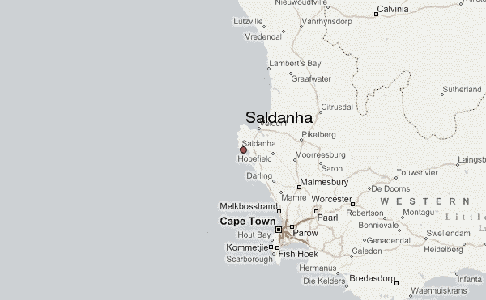
The West Coast Development SDI. –SALDANHA BAY

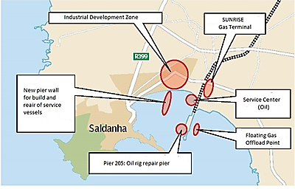

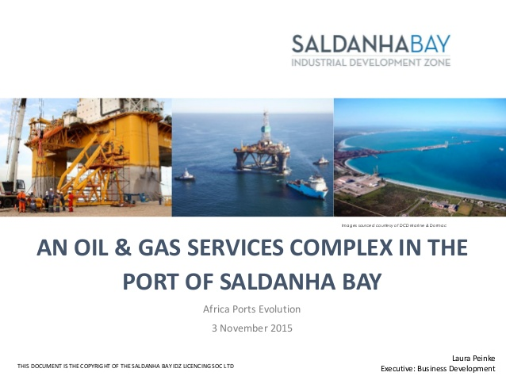

AIM

The Spatial Development Initiative (SDI) programme is a short-term investment strategy that aims to unlock inherent economic potential in specific spatial locations in southern Africa. The programme uses public resources to promote private sector investment in regions with a high potential for economic growth
Where
- West Coast Investment Initiative. [WCII]
- Centred on regions around SALDANHA BAY (2019) on the Cape West Coast.

What
- Over the years, the port had developed into a modern harbour when it became necessary to facilitate the export of iron ore from the Northern Cape. These developments required the construction of a railway more than 800km from the mines at Sishen in the Northern Cape and the establishment of a deep-water jetty in Saldanha Bay to accommodate the extra - large ore carriers.
- During the mid-nineties the West Coast being designated as one of five Spatial Development Initiatives (SDI’s) in South Africa. From 1997, over a period of three years, structures were established, projects were developed, and international investors were approached culminating in an investment conference in 1999 where some 200 projects were presented to a high level conference of international investors and government officials.
- For the Saldanha–Vredenburg IDZ the key economic strategies revolve around industry, tourism, fishing and agriculture, with a key aspect of the industrial strategy being an increased emphasis on minerals beneficiation and minerals processing.
- Projects in mining and mineral beneficiation, fishing, agriculture, tourism and infra structure – valued at around R20 billion.
- The R6,8bn Saldanha Steel facilities, situated on the Cape west coast roughly 10 km away from Langebaan Lagoon's ecologically sensitive wetlands, has been designed to produce 1.25 million tons of hot-rolled carbon steel coil per year. The mill was commissioned in 1998.
- 120 projects that are ready for investment are expected to create some 20 000 jobs.
- Expanded opportunities for mineral beneficiation and processing have been identified as a key pillar for the success of the Saldanha–Vredenburg industrial development zone (IDZ). In fact, if identified projects come on stream, the IDZ looks set to become a key minerals-processing zone in the Western Cape’s West Coast region.

- Saldanha’s under-utilised harbour facility, together with the implementation of a ‘one-stop shop’ aimed at easing investors’ dealings with regulatory authorities, provide fertile ground for expanded investment in export-orientated mineral beneficiation and processing.
- Incentives; Parastatals like Spoornet and Portnet will have to make rail tariffs and port charges more internationally competitive. For example, these costs in South Africa are at present three to four times higher than the cost of passing material through State-owned ports in Australia.
- The production of magnesium metal – mainly for the production of aluminium alloys and for the diecasting of cars parts. Envisaged capital expenditure on such a project would be more than R700-million and would create about 350 employment opportunities.
- Other mineral-processing possibilities identified within the IDZ and the broader West Coast Investment Initiative include the production of titanium dioxide pigment, silicon metal, zinc metal and magnesium metal.
Highlights
- The Anglo American Corporation would take up one of the initiatives biggest projects and build a R1.6 billion zinc smelter at Saldana Bay port area.
- The Saldanha Bay Industrial Development Zone (SBIDZ) was officially designated as South Africa’s fifth Special Economic Zone (SEZ) on the 31st October 2013.

Phalaborwa SDI
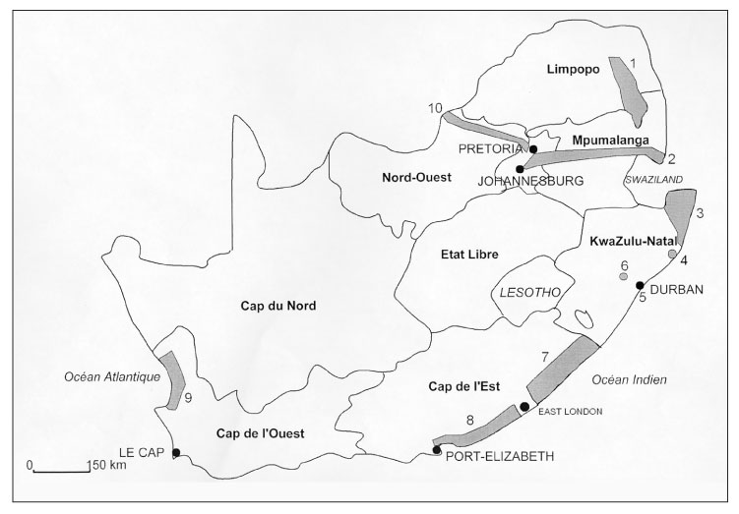
AIM
The Spatial Development Initiative (SDI) programme is a short-term investment strategy that aims to unlock inherent economic potential in specific spatial locations in southern Africa. The programme uses public resources to promote private sector investment in regions with a high potential for economic growth
WHERE
Limpopo is the natural resource treasure chest of South Africa. It boasts some of the greatest reserves of agriculture, mineral and tourism resources, many of which remain hugely underexploited. A unique feature of this province is that it shares borders with three countries namely Botswana, Mozambique and Zimbabwe. The province is also linked to Maputo Development Corridor through the Ba-Phalaborwa Spatial Development initiative, a network of road and rail corridors connecting to the major seaports set to open up Limpopo and the surrounding regions for trade and investment.
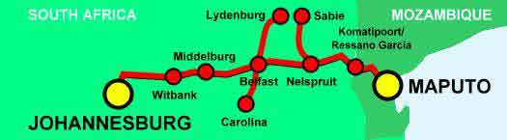
- The Phalaborwa Corridor connects Hazyview (Mpumalanga) with Phalaborwa and Tzaneen through a number of small towns on the western side of the Kruger National Park. It includes two roads sections that fall within the Sekhukhune area.
Phalaborwa SDI
- Creates better access between the Port of Maputo and mining potential in and around Phalaborwa and the agricultural projects near Xenon in South Africa's Northern Province.
- Phalaborwa has been declared a Spatial Development Initiatives. The objectives of the SDI is to exploit the unutilized and underutilized potentials of the area by combining private and public sector resources in a sustainable manner.
- There are number of mega projects that mining companies have been considering for implementation or exploration in the district. This includes the expansion of rock Phosphate production by FOSKOR, the Phlogopite processing facility, the Kaolin clay project, institution of underground copper mining operations at Phalaborwa, surface strip mining of mineral sand in Gravellotte area, exploitation of heavy mineral deposits in the Tzaneen area (by Red River mining and ISCOR), erection of a steel production facility
- Agriculture is the backbone of any developing economy. It is the sector that is able to create more sustainable jobs, absorbing even the unskilled and semiskilled workers, and as such bring about sustainable rural development.
- The district (Lowveld region) contributes significantly towards the activity of agriculture on the provincial level. About 50% of the farm income in the province in Horticulture is earned in the district. Most important crops in terms of monetary value are citrus, vegetables and subtropical fruit. 6,7% of the land can be considered arable of which 43% is under irrigation, which by far the most of all districts in the province.
- The most important irrigation schemes in the region are Lower Letaba, Blyde irrigation and Middle Letaba. The region has future agricultural potential highly concentrated in subtropical fruit, citrus fruit production and vegetables. Unutilized potential is estimated at between 10 000 to 70 000 hectares.
- According to the Provincial Economic Development Strategy, 10, 000 hectares of this potential could be brought into production over the next 5 years, mainly in new orchards in the Letaba/Letsitele basin area and about 1500 hectares in the Klein Letaba area.

